# Release Plan

The team has chosen Case Study 2 as the subject of our research and recommendations. The work will be done following the structure outlined below:

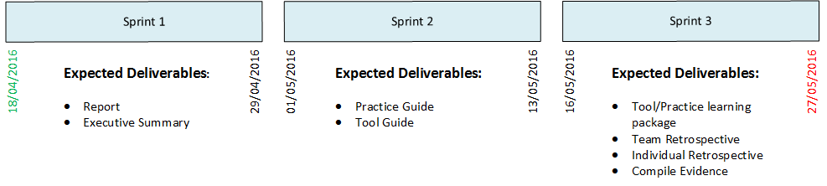

In Sprint 3, ‘Compiled evidence’ has been listed as one of the expected deliverables. This is to ensure that the team understands that a final check would need to be done to ensure that all of the required evidence is included in the final submission.

**Breakdown and effort estimations of tasks required**

|  |  |  |
| --- | --- | --- |
| Deliverables | Tasks | Effort |
| Report | Research into Practices | 5 |
| Write Abstract | 2 |
| Write Introduction | 3 |
| Write Analysis | 8 |
| Write Conclusion | 5 |
| Executive Summary | Formulate content from report | 3 |
| Design Layout | 1 |
| Practice Guide (Describe in terms of) | Collaboration and Communication | 2 |
| Requirements Engineering | 5 |
| Project Planning/Tracking | 3 |
| Managing Change | 2 |
| Quality Assurance | 5 |
| Tools Guide | Identify/Find Tools | 1 |
| Justify usefulness | 3 |
| Learning Package | Design Learning Activity | 3 |
| Design Learning Sessions | 2 |
| Write explanation of learning package | 8 |
| Retrospectives | Summarise Team Retrospective meeting | 2 |
| Produce Individual Retrospective | 2 |
| Compiled Evidence | Compile produced evidence collected throughout project | 3 |

These tasks will be put into a Kanban board, where team members will self-select the items they wish to work on. These tasks are time boxed into Sprints (shown above), where the team is expecting to finish the listed deliverables.

Work in Progress will be shared with the team via a shared folder on Google Documents, as it provides useful tools for collaboration and full history of edits. When tasks are completed, the section is merged with the main document, and is committed to the Github repository.